**Test condition**

**Target** 100m

**Car** Mass 1,Friction 0.1 ,Resistance 0.01 ,Period 0.1 ,Lag 2

P 1 I 0.0 D 3

E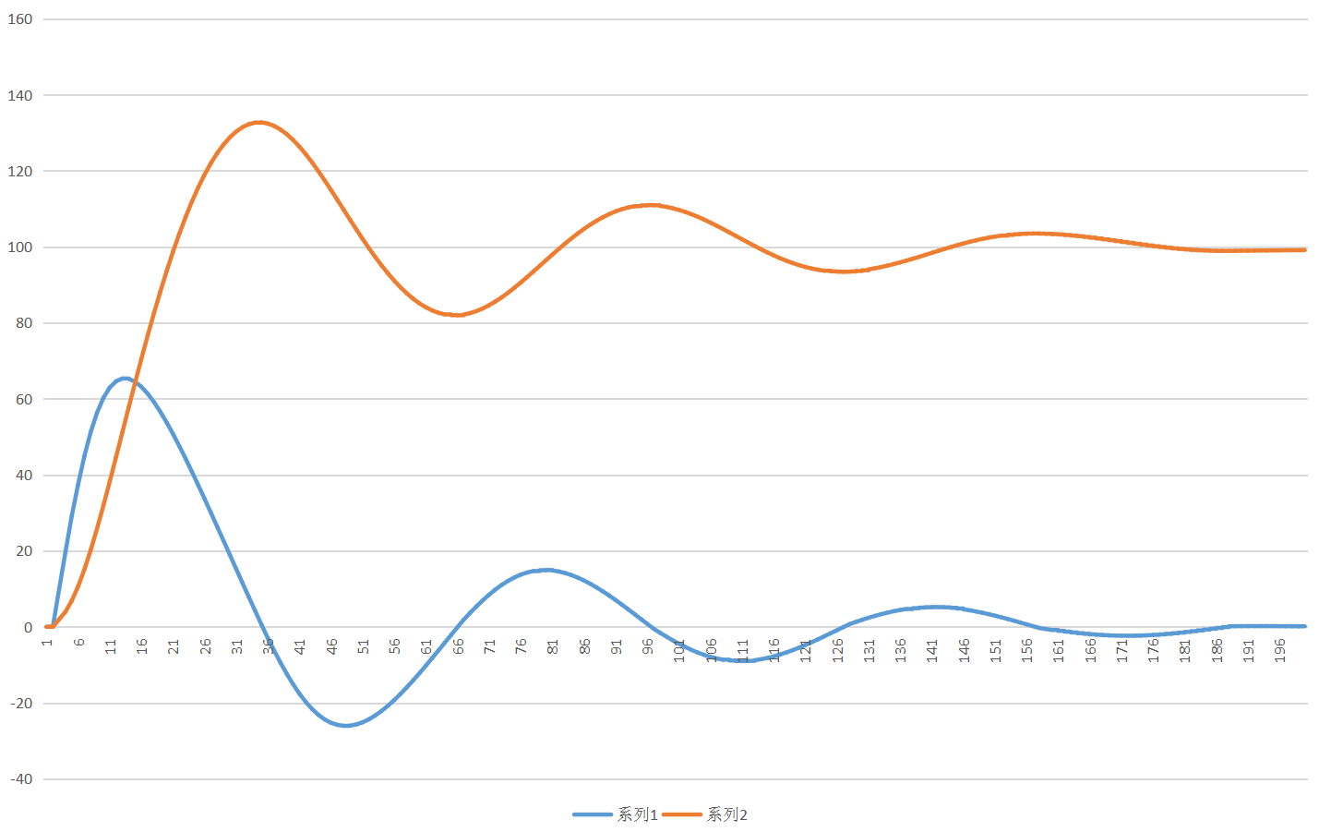

**Test condition**

**Target** 100m

**Car** Mass 1,Friction 0.1 ,Resistance 0.01 ,Period 0.1 ,Lag 2

P 3.53 I 0.0 D 21.384

E